MORNING WORSHIP SERVICE
Oct 11, 2015

Opening Song “Do Lord”

Opening Prayer/Announcements

Worship Hymns “O Worship the King” 16
“Amazing Grace, My Chains are Gone”
“There Is Power in the Blood” 132
“Speak to My Heart” 281
“My Only Hope Is you”

Offering/Offertory

Special Music Curtiss Waggoner

Message Bro. David Atwood
.
Invitation “Take My Life, Lead Me Lord” 287

Closing Prayer

Evening Service at 6:00

Living Proof Live
March 4-5, 2016 (Fri & Sat)
Waco, TX: Extraco Event Center
Contact Patti Radford if you might be interested in attending

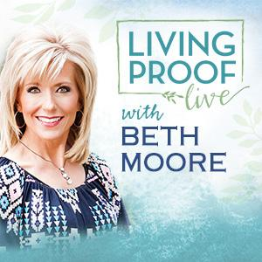
NURSERY – available for children age 0 to Kindergarten
Tami Knipstein

Hostesses for October Ushers for October
Diann Stutes, Evelyn Robinson, Sam McManus, Wesley McManus,
Hugo & Carolyne Breithaupt Joe Wilson, Bobby Stutes

Immediate Need Prayer List
Prayer & Request Information

(Please complete name & address information on reverse side)

I would like to speak with the Pastor.

I would like more information on this church.

I have Prayer Requests or Needs

Date:

Permission to Publicize:
Church Bulletin Yes No
Email Prayer Chain Yes No

Prayer Request:

Prayer For
Name
Address
Phone

Given By
Name
Address
Phone
Please Contact By

Card Phone Visit

Comments

Pray Diann Stutes as she recovers from bronchitis issues

Pray for Danny Sherman as he recovers from by-pass surgery

Pray for the family of Ella Amstead (David’s aunt)

Pray for Ervin Griffith as he recovers from illness

K s b c

Keeping His Word through Sunday School, Bible Study and Church Attendance/Worship

Sunday School Bible Studies for October:

Oct 4th God’s Promise of Victory Romans 8:28-39 Oct 11th God’s Promise of A New Home Revelation 21:1-8
Oct 18th Develop Conviction Daniel 1:3-5,8-13,17-19
Oct 25th Pray Fervently Daniel 2:13-21,26-28a

9:45 a.m. each Sunday – A place for everyone

WE’D LOVE FOR YOU TO JOIN US!

